Hotel Reservation Cancellation Analysis (Excel)

Name: Anuvind Pradeep
1) What percentage of customers canceled their booking in the training and test dataset? Is it similar in both the files?
- In Testing data:
The total number of bookings is 7255.
The number of cancelled bookings is 2377.
Percentage of cancelled booking => (2377/7255) *100= 32.763%
The percentage of customers cancelled their booking in test dataset is 32.76%. (shown in the below figure)
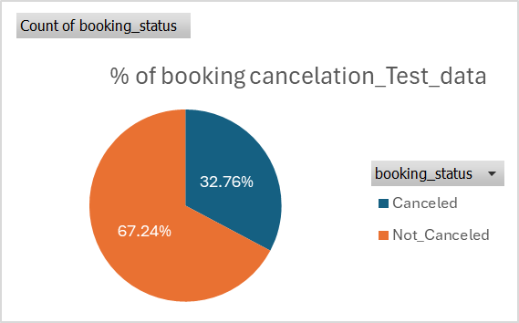
- In Train data:
The total number of bookings is 29020.
The number of cancelled bookings is 9508.
Percentage of Cancelled booking => (9508/29020) *100=32.763%.
The percentage of customers cancelled their booking in train dataset is 32.76%. (shown in the below figure)
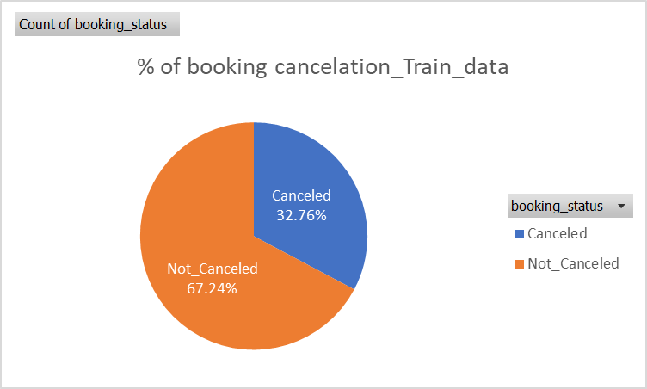
The percentage of customers canceled their booking in the training and test dataset are same.

2) What are the top three months with the highest average bookings? Justify your findings with an appropriate chart.
- In test data set:
The top 3 months with the highest average bookings in the test data set, considering only the bookings status as not cancelled are October, September, December.
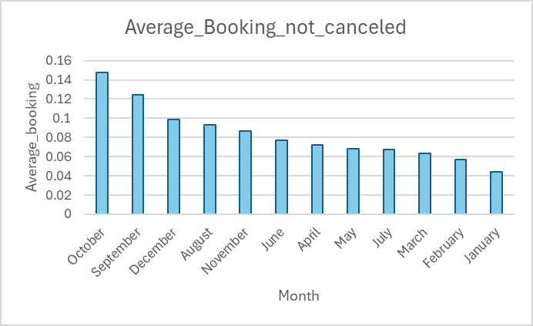
But when we consider top 3 months with the highest average bookings in test data set considering all the bookings including cancelled one then October, September, August stand on the top 3 position.
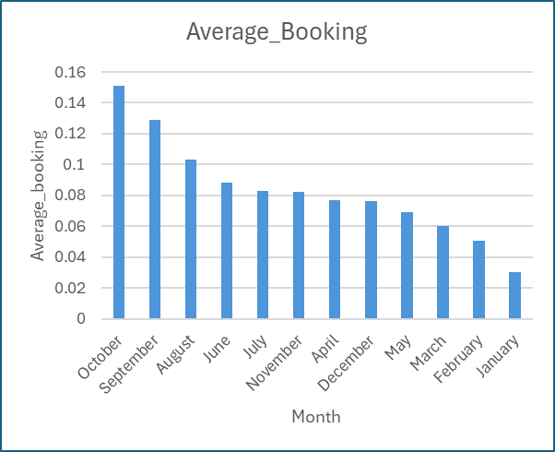

- In train dataset:
The top 3 months with the highest average bookings in train data set considering only the booking_status as not cancelled bookings are October, September, December.
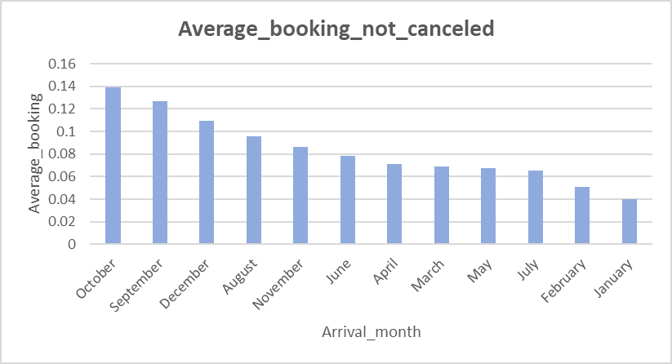
But when we consider the top 3 months with the highest average bookings in the train data set, considering all the bookings including cancelled bookings, then October, September, August stand in the top 3 position.
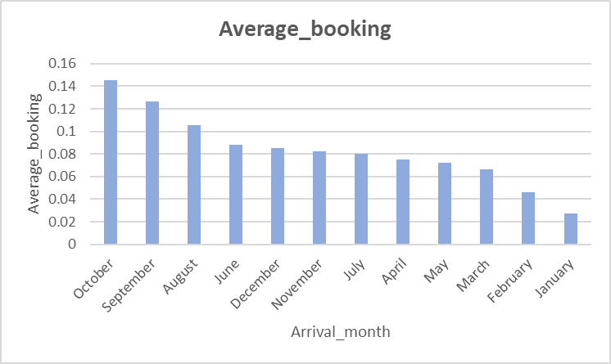
- Which months have the highest and lowest average price per room?
In test dataset: September and January have the highest and lowest average price per room respectively.
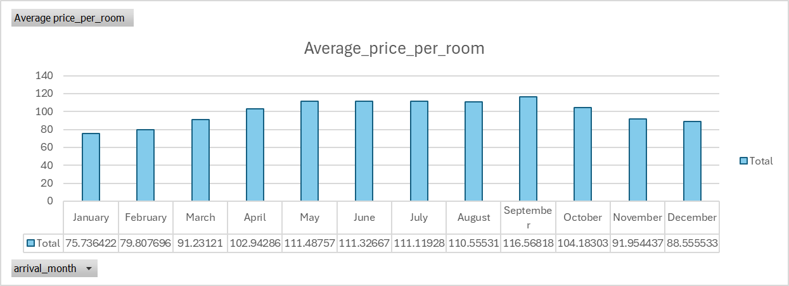
In train dataset: September and January have the highest and lowest average price per room respectively.
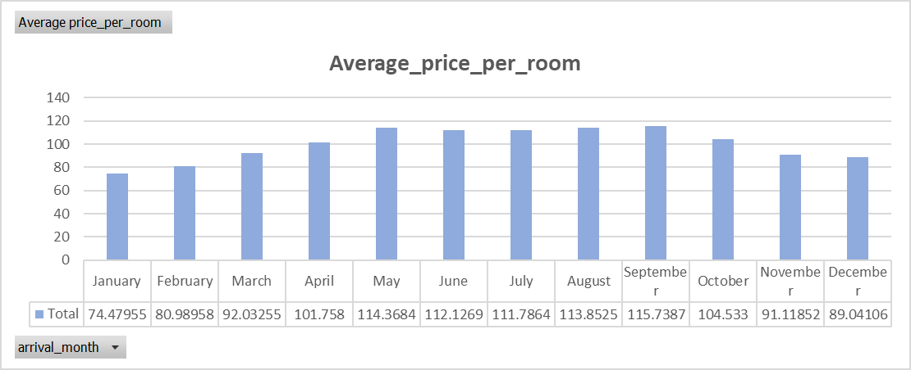

- You would like to create a machine learning model to be able to predict whether your customers would cancel their reservations using the data provided to you. Which model would you use for this purpose: linear regression or logistic regression? Why?
Ans: We will use Logistic regression to create the model. Logistic regressions are used when the target variable is not in continuous form. So, in this case it is not continuous, and it is in categorical form
(binary) so logistic regression would be the best choice to build this predictive model.

- Create/train the machine learning model as per your response in Q4. Use the data in
‘Hotel_reservation_train.csv’ file to train your model. For the feature ‘room_type_reserved’, use ‘Room_Type_1’ as your reference, and for the feature ‘arrival_month’, use ‘January’ as your reference. Ans: We are performing OneHotEncoding for the columns “room_type_reserved” and “arrival_month”. By performing “OneHotEncoding” taking ‘Room_Type_1’ as reference for ‘room_type_month’ field we are creating 6 other dummy variables as one hot encoded column and not including the ‘room_type_1’ column. Similar way we are taking 'January' as the reference for 'arrival_month' and including 11 other months as one hot encoded column in the model and not including a column for January. Please find the attached below excels for the predictive models.

- What is the baseline accuracy for your model? Baseline accuracy can be defined as the accuracy you would obtain if you predicted all the examples in your dataset as belonging to the majority class from your target variable.

Test:
Base line Accuracy | 0.672363887
Train:
Base line Accuracy | 0.672363887

- What is the accuracy, recall (true positive rate), precision, F1 score, and false positive rate of your model at the threshold of 0.5 on the training dataset. Is your model accuracy better than the baseline accuracy?
Evalution metrics
Accuracy | 0.782288077
Precision | 0.717243258
Recall(True postive Rate) | 0.55384939
F1 score | 0.62504451
False postive | 0.106396064
Yes, the model accuracy is better than the baseline accuracy.

- Use the model you trained to make predictions on the testing dataset (‘Hotel_reservation_test.csv’). What is the accuracy, recall (true positive rate), precision, F1 score, and false positive rate of your model at the threshold of 0.5 on the test dataset. How do they compare with the testing dataset?
Evalution metrics
Accuracy | 0.789110958
Precision | 0.727321524
Recall(True postive Rate) | 0.570046277
F1 score | 0.639150943
False postive | 0.104141041
Overall, these findings suggest that the model performs consistently well on both the training and testing datasets, with a slight improvement in performance observed on the testing datasets. The results are almost similar in both the test and train datasets.

- Create a chart with ROC curves for the training and the testing datasets.
Train Data Set:


0
0.2
0.4
0.6
0.8
1
1.2
0
0.2
0.4
0.6
0.8
1
1.2
True Postive Curve
False Positive curve
ROC Curve
Test Data Set:
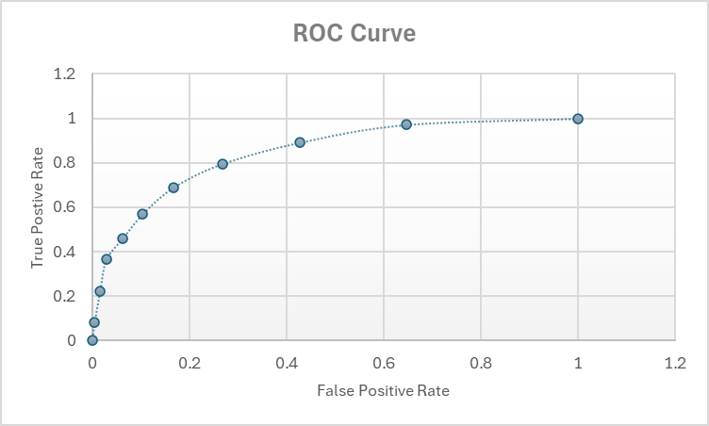
- Interpret the meanings of the coefficient values for the variables ‘lead_time’ and ‘arrival_month’ of ‘November’.
An increase of 1 in lead time corresponds to 1.01 times increase in the odds of someone canceling their booking. Additionally, individuals arriving in November are 12.99 times more likely to cancel their booking compared to those arriving in January.

